Year 7

Term 1 Test

Name: ______________________ Class: ______ Time: 50 minutes Total Mark:____/45

Show working and answers on this sheet. Show working in sufficient detail to support your answers. Incorrect answers without supporting reasoning will be allocated zero marks.

Resources: 1 A4 page of notes (1 side), Calculator allowed.

Question 1 6 marks – ½ mark each

Fill in the blanks in the table by converting between fractions, decimals and percentages.

Fraction  (in simplest form) | Percentage % | Decimal
$$\frac{26}{100}$$
 |  | 0.4
 | 85%


Question 2 4 marks

- Bob is a baker and every morning he uses 25% of his flour delivery to make big soft pretzels to sell to his customers. If Bob got a delivery of 18kgs of flour on Tuesday morning, how much did he use to make pretzels on Tuesday? Show your work.

- Billy gets $15 allowance every week from doing his chores. Billy’s parents make sure he saves $\frac{2}{5}$ of his allowance every week, so he doesn’t waste it all on soft pretzels. How much does Billy save each week? Show your work.

Question 3 2 marks

Round both numbers to the leading digit and solve using estimation.

$$489-45=$$

Question 4 1 marks

Simplify the fraction $\frac{80}{100}$

Question 5 1 marks

How many parts of the whole shape are shaded?
Write you answer as a fraction in the simplest form.

Question 6 2 marks

Convert the following measurements.

4.2 km = cm

40.3 m = mm

Question 7 6 marks

Find the perimeter of the following shapes. Show your work
7 m

- b.
10 cm
3 m
5 cm

10 m
8 cm

5 mm

c.
8 mm

10 mm

Question 8 7 marks (2,2,3)

Find the area of the following shapes. Show your work.
7.5 mm
- b.

4 cm
10 mm

12 cm

c.

22 m
11 m

22 m

Question 9 3 marks

Jenny made a poster for Pink Stumps day, initially she had a rectangular bit of cardboard but she cut out a triangle in the bottom right hand corner. Jenny painted the remaining cardboard with bright pink paint, what is the area that Jenny painted bright pink? Show your work.

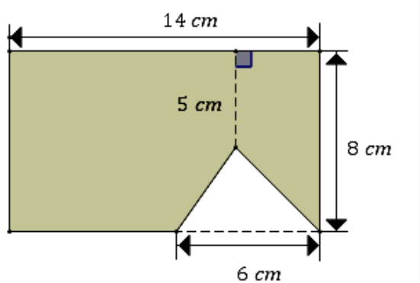

Question 10 3 marks

The spinner is divided into eight equal sections and labelled with specific colors.
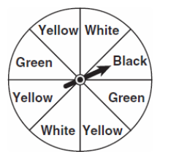
- What is the sample space for the spinner?

S= {_______________________________}

- What is the probability of getting black?

- What is the probability of getting yellow or green?

Question 11 5 marks

Complete the table by choosing a descriptive word from the word bank for each of the five situations. Then place the symbol on the probability scale where it should belong.

Word bank:
Unlikely, Very likely, Even-chances, Impossible, Certain, Likely, Very Unlikely

Symbol | Situation | Descriptive Word
 | Rolling a dice and getting an odd number
 | Winning the lottery
 | Flipping a coin and it landing heads up
 | Pulling a Queen of hearts out of a standard deck of cards
 | Rolling a dice and getting a number less than 6

1
0

0.5

Question 12 3 marks

There is a bag with 15 marbles in it. In the bag there are 4 glass marbles, half of the glass marbles are red the other half blue. There are 3 wooden marbles, 1 of them is black the others are green. The rest of the marbles are made of plastic and $\frac{1}{4}$ are green, the remaining ones are red.

- What is the probability of choosing a blue glass marble?

- What is the probability of choosing a green marble?

- What is the probability of choosing a black or red marble?

Question 13 2 marks

Explain the difference between theoretical probability and experimental probability.

END OF TEST

